Bug_01:

Size should be little bit large
Bug_02:
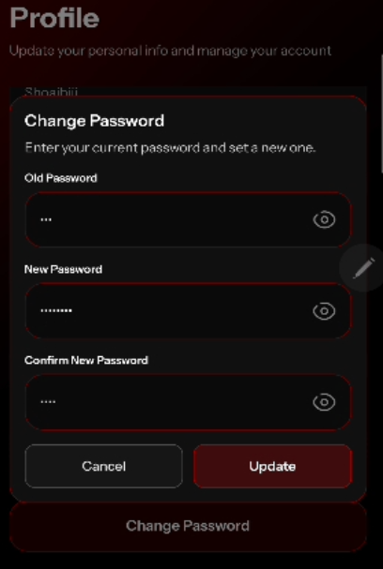
Error message should be show below the fields.
Bug_03:
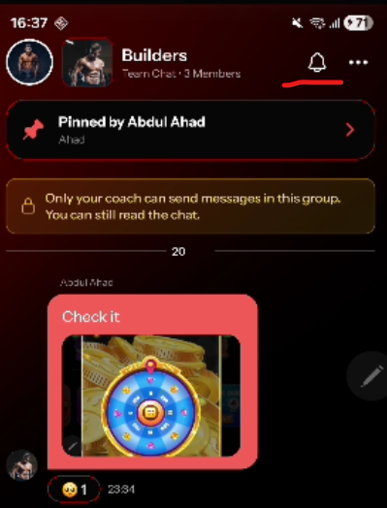
Bell icon response time issue
Bug_04:
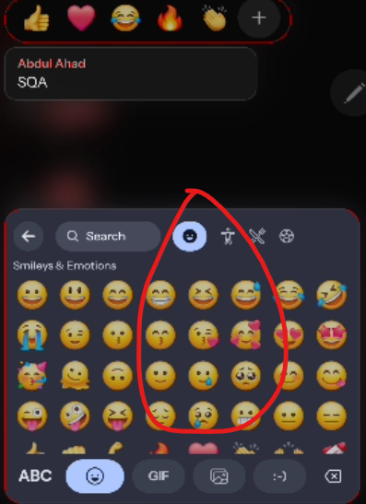
Emogi’s should b bright in color

Bug_05:
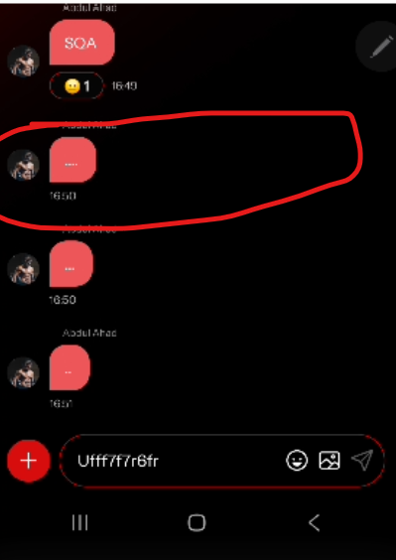
When user press any message, the message should be highlight

Bug_06:
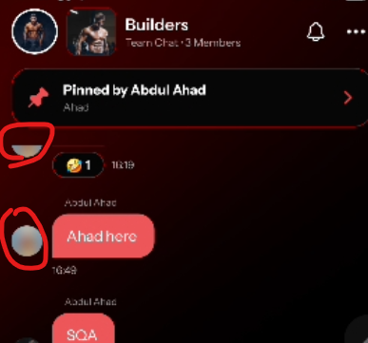
Taking too much time to refresh the page

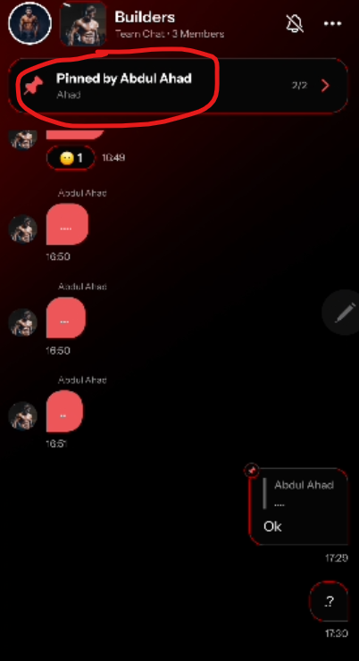
Bug_07:

Taking too much response time
Bug_08:
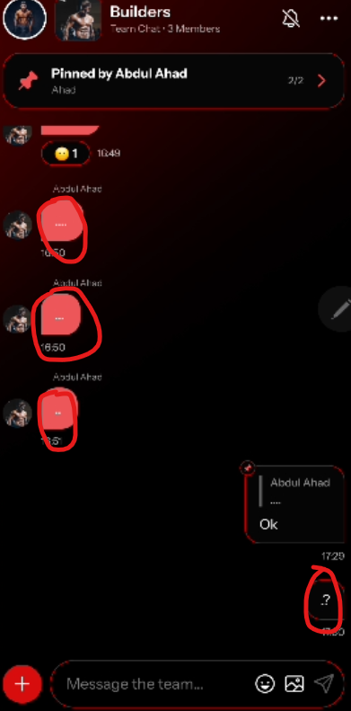
Difficult to click on these small messages

Bug_09:
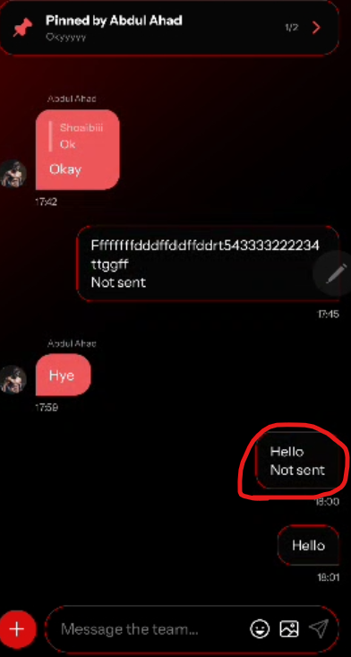

Bug_10:
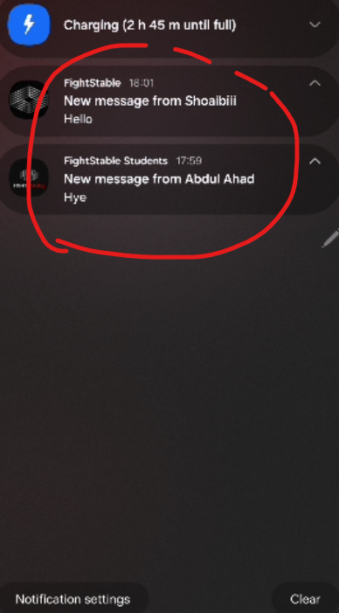
These notifications should be removed when user already open the chat

Bug_11:
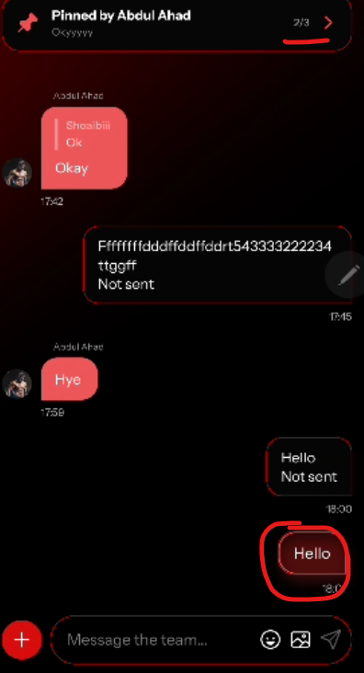
This message is not pinned but still shows in pinned messages
Bug_12:
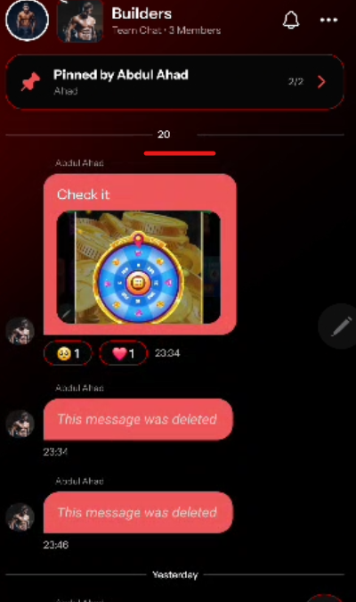
20 May
Bug_13:
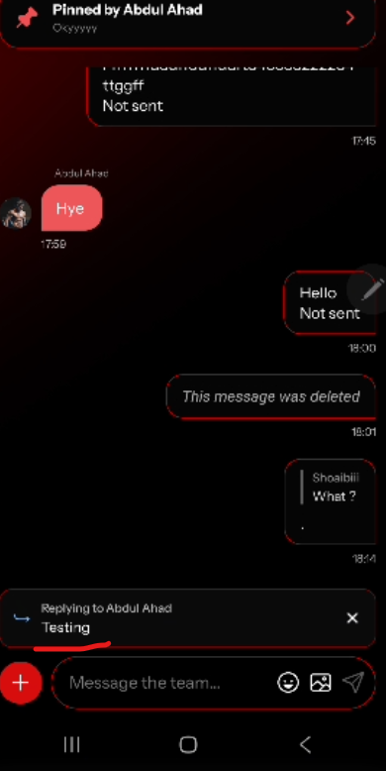
When click on this message, it should redirect to this text message place

Bug_14:
When user goes offline, it should show popup like no internet/offline
and when user back to online, it should show like internet restore
Bug_15:
Offline chatting is not working/sync.
User sent message while offline but when back to online message should be send or ask to resend the message

